The handout round : Team Name ...................................................
Name the television programmes in which the following characters appeared. |  |  |  |  | 13 different players have been sent off in a full International match for the England football team. Who are they ? |  | 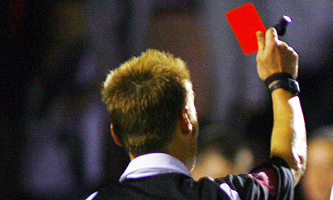
1 | Albert Stroller |  |  |  | 1
2 | Ben Cartwright
3 | Hildur Odegard |  |  |  | 2
4 | Maurice Yeatman
5 | Joseph Molesley |  |  |  | 3
6 | General Melchett
7 | Saul Berenson |  |  |  | 4
8 | David Stockwell
9 | Tyrion Lannister |  |  |  | 5
10 | Justice Stephen Rawley
11 | Demelza Carne |  |  |  | 6
12 | Chris Finch
13 | P C Ernie Trigg |  |  |  | 7
14 | Beth Latimer
15 | June Snell |  |  |  | 8
16 | Dan Griffin
17 | Miss Tibbs & Miss Gatsby |  |  |  | 9
18 | Kirk Sutherland
19 | Alice Tinker |  |  |  | 10
20 | Paul Milner
21 | Susan Harper |  |  |  | 11
22 | Pearl Ladderbanks
23 | Billy Blue Cannon |  |  |  | 12
24 | Bert Spooner
25 | George Cowley |  |  |  | 13
26 | Sidney Chambers

